Research Content Management

Software Requirements
React
Git
Firebase
Vs Code

Team Members

Abhinav Bellamkonda
Vamsidhar Reddy
Nithin Reddy Kumbham
Saivivek Reddy Kusukuntla
Gopi Krishna Kandimalla
Jawahar Reddy Nomula

Submitted in partial fulfilment
Of the requirements of
CSIS 44-691 Graduate Directed Project 1

Table of Contents

Table of Contents

- Introduction
  - Purpose
  - Scope
  - Definitions, Acronyms, and Abbreviations
  - Overview
- Product Description
- Specific Requirements
  - External Interface Requirements
    - User Interfaces
    - Software Interfaces
    - Communications Interface
  - Functional Requirements
  - Use Cases
  - Non-Functional Requirements
3.4.1. Performance
3.4.2. Reliability
3.4.3. Availability
3.4.4. Security
3.4.5. Portability
4. Design
4.1. ER diagram
4.2. GUI
5. Steps to create and run the application
1. Introduction
1.1. Purpose
Research is an ever-growing study involving identifying and working on the problem and finally finding an appropriate solution or advanced solution for the existing one. The work being done in the background involves a lot of work and skill. If above problem is the primary task for people who are working on research and the secondary problem is storing them appropriately in database using some sort of technology and retrieving them for future use. In this paper we further discuss how research papers can be stored and retrieved for future use using software website and database to store papers physically.
1.2. Scope
Research Content Management is a website where individuals can store and retrieve stored papers in a single go creating ease of access by using search techniques and adding comments for specific papers creating a reference point. The main backbone of Research Content Management is React JS library and firebase for storing user data and papers in server with individual account.

1.3. Definitions, Acronyms, and Abbreviations
- React: React is an open-source JavaScript library created by Facebook for creating interactive websites and standalone applications.
- Git: Git is a version control where developers or teams can collaborate to work on single application or project.
- Vs Code: Visual Studio Code is an IDE where developers can write the code and execute their work locally on their machine.
- Firebase: Firebase is a product owned by google where it acts like a database for storing data related to applications.

1.4. Overview

Research Content Management is designed for researchers for storing user data and research papers which they worked on. It is mainly a website with React JS acting as backbone in the front and Firebase for storing user data in the cloud server. The website is designed with ease where it involves registering an account for storing user data, storing research papers with adding title, date, topic, research area so that the added paper will be unique and can be retrieved easily using appropriate search techniques by using above provided data. The retrieved paper can be viewed with ease and future reference comments can be added.

2. Product Description

Research Content Management is designed and implemented in such a way that it contains blocks which act as components in React JS and together combined makes a full website. The blocks involve
- Register
- Login
- Dashboard
- Upload
- Search
- View
2.1. Register
For the use of Research Content Management user needs to register for the website and for the ease of use RCM has an option to register using manual fill up of data i.e., Name, Email, and password. The other option for registering is through Google. If one has a valid google account saved in his local machine, he/she can register at a glance using the above mentioned feature. The authentication requirements provided by firebase are needed to meet like password should be minimum of 6 characters in length and email address should end up with .com.
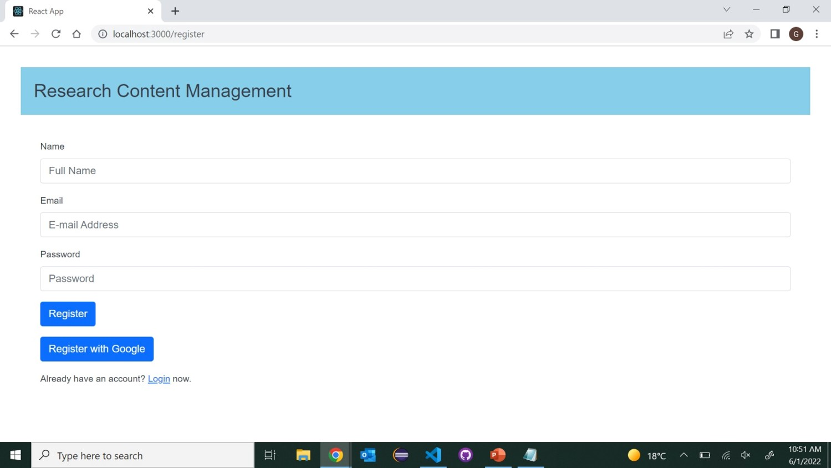

2.2. Login
Once user had successfully created/registered an account he/she can login to website using the provided email address and password. User can login with Google account as the option of registering using Google is provided during registration. If the user had forgotten his/her password the website provides an option for forgot password link where the user will be getting a link to reset the password when user enters email address which he used during registration.
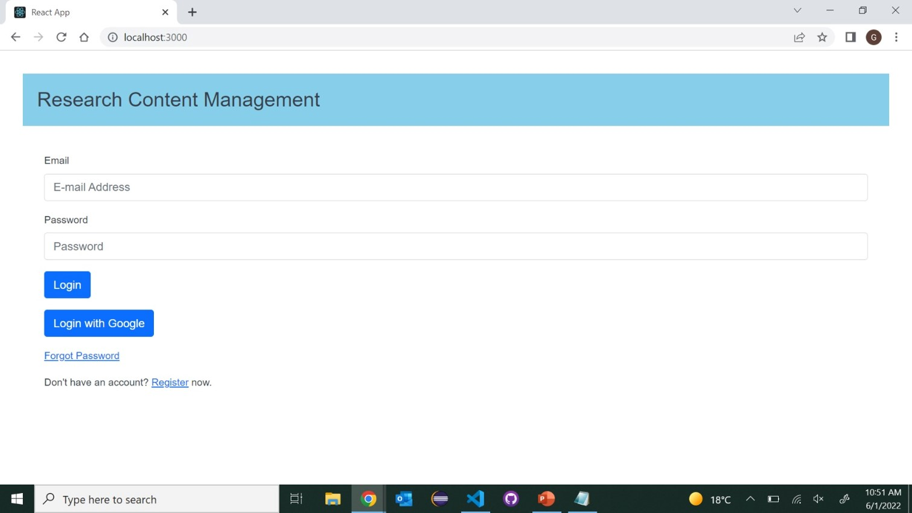

2.3. Dashboard
Once user had logged in successfully the user can see a dashboard at the top where the dashboard consists of website name to the left and to the right user can see his name, email address and logout button to the right. This dashboard gives user a quick glance of user details.

2.4. Upload
Upload feature makes a user to upload a research paper on which he is currently working or previous research papers which he/she worked on. For making the uploaded paper unique there are several factors taken into consideration. The paper which user wants to upload should be of pdf format, should choose a topic for the paper, year of publishing for the paper, title of the paper, and finally technique of the paper by choosing above metrics the paper will be unique with all the papers which are previously uploaded or the papers which are being uploaded in the future. And when user clicks on submit button the data which is entered is directly uploaded to the firebase server which later can be accessed.
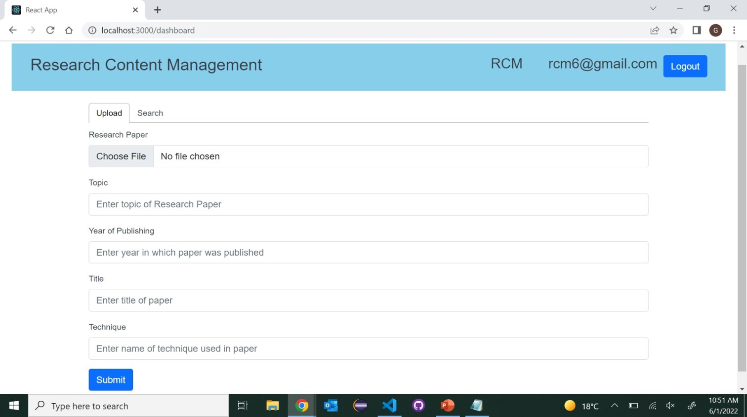

2.5. Search
Search component is used to search a particular paper from list of papers in list which user had uploaded into database. Whenever search link is clicked on dashboard initially all the papers being uploaded is displayed as list with columns title of paper, year, topic, technique, view pdf button to view the paper. At the top of list there is a search button where user can search the paper using topic, year, title, and technique. Effective search technique is used to filter out particular paper using keyword search.
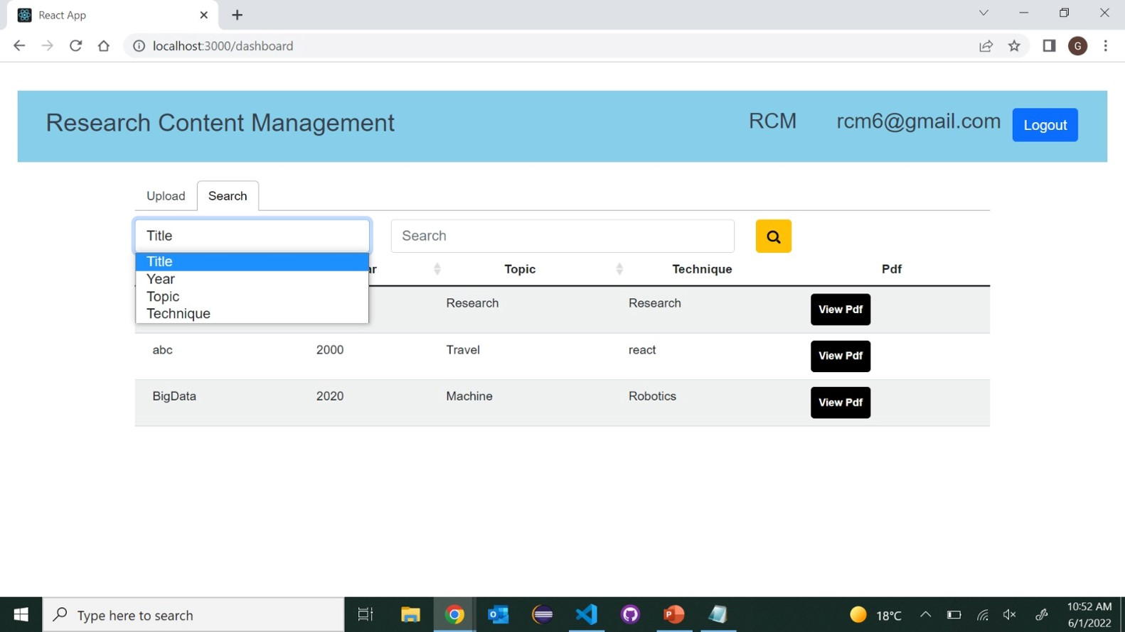

2.6. View
View component is used to view a particular paper when view pdf button is clicked. When view pdf button is clicked the paper is displayed to the left and comment section box will be displayed to the right. If the user wants to add comments for respective paper he/she needs to enter the comment in comment box and click on post comment then the comment for the paper will be stored in database with timestamp. When user clicks on show comments button the comments which are posted for the paper is displayed as list with the timestamp.
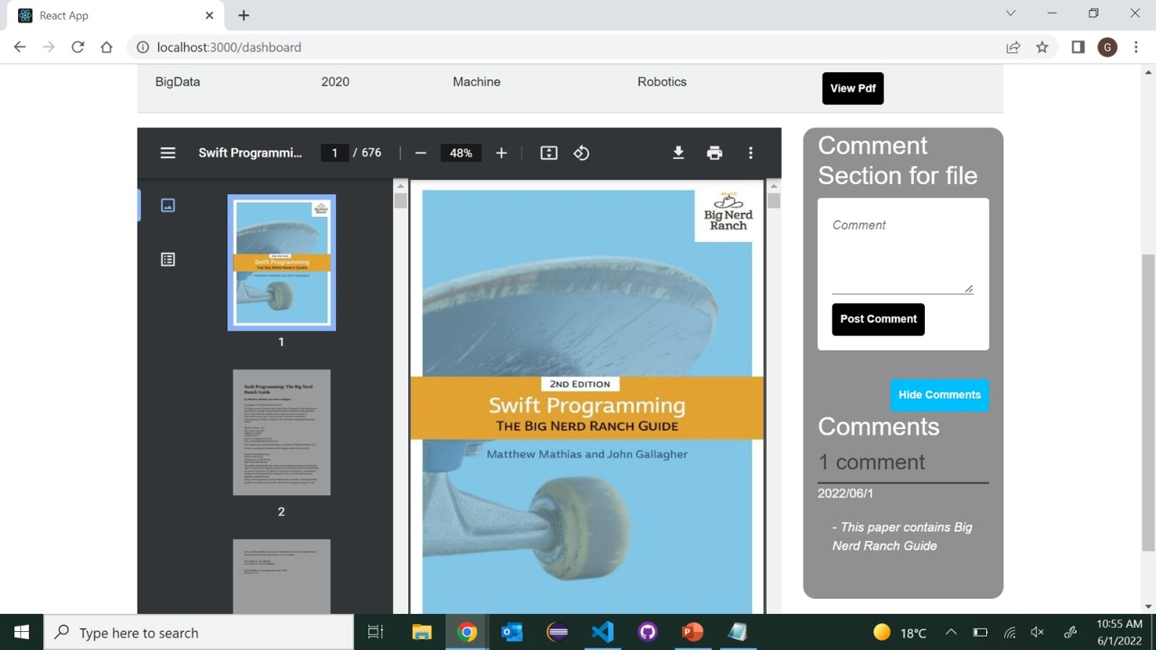

3. Specific Requirements
3.1. External Interface Requirements
3.1.1. User Interfaces
User can login to the application using his/her credentials. If the user don’t have an account he/she can sign up by going through the register link provided in login page. The first page user sees is the login page, and it acts as parent for the application.
3.1.2. Software Interfaces
The software used in creating Research Content Management is React where it is an open source JavaScript library created by Facebook. React is designed to create interactive websites and standalone applications. Firebase which acts as primary storage for the application where all the user data is stored and retrieved accordingly. Git is another software where developers can collaborate and work on single application simultaneously. Visual Studio Code is an IDE where developers can write their code that’s need an application to run.




3.1.3. Communications Interface
Users can interact with Firebase by logging in to application and perform search operations to the uploaded research papers or if the user haven’t uploaded one he/she can upload into database for further reference. The only communication that Research Content Management has is through passing and getting data from Firebase.

3.2 Functional Requirements
Research Content Management contains a login page to login to the application and it identifies the user based on the credentials. There are some authentication rules set by Firebase for registering into application. All the application code is written in React where it allows the user to surf through the application with ease navigating between different sections of the application. The application is designed in such a way that it is easily understandable to user with no complex sections.

3.3 Use Cases
User first enters into application and register himself as a user for logging in. If the user is a returning user he/she can directly login to application. As the application is primarily designed for storing research papers user can store research papers which he had done so far without worrying that the papers might be misplaced or lost when stored physically. Application has several inputs to enter asking the user what the title of paper is, technique, year, topic making the uploaded paper unique from other uploaded papers previously. Uploaded paper can be searched with ease as the data entered during upload process makes it easy to search. Uploaded papers will be displayed as list and there will be an option to view pdf when clicking on it user can view his uploaded paper as pdf format where he/she can add comments further.

3.4. Non-Functional Requirements
3.4.1. Performance
Research Content Management application is written in React and is integrated with Firebase with less complex components. Performance of the application is fast and user-friendly. Users can navigate between different sections of the application with ease.
3.4.2. Reliability
Research Content Management application delivers correct output to the user from start to end. Users can retrieve any stored paper with ease and add comments for further review and update it accordingly. The application delivers what it needs to perform and asks inputs accordingly so that the application can work accordingly.
3.4.3. Availability
Research Content Management is free to use for any users. As the application is designed keeping in view of various users where they can store their research work and retrieve for further use. Users can create an account and login with their credentials and upload and retrieve papers for further use.
3.4.4. Security
Application is protected with authentication provided by Firebase where it doesn’t allow other users to use some others account until and unless the login credentials are misused. Firebase has various inbuilt authentication steps to register or login just by enabling and using the features in code.
3.4.5. Portability
Currently the application is designed as web application. The application runs on server side so there is no restriction for any systems other than mobile devices.

4. Design
4.1. ER Diagram
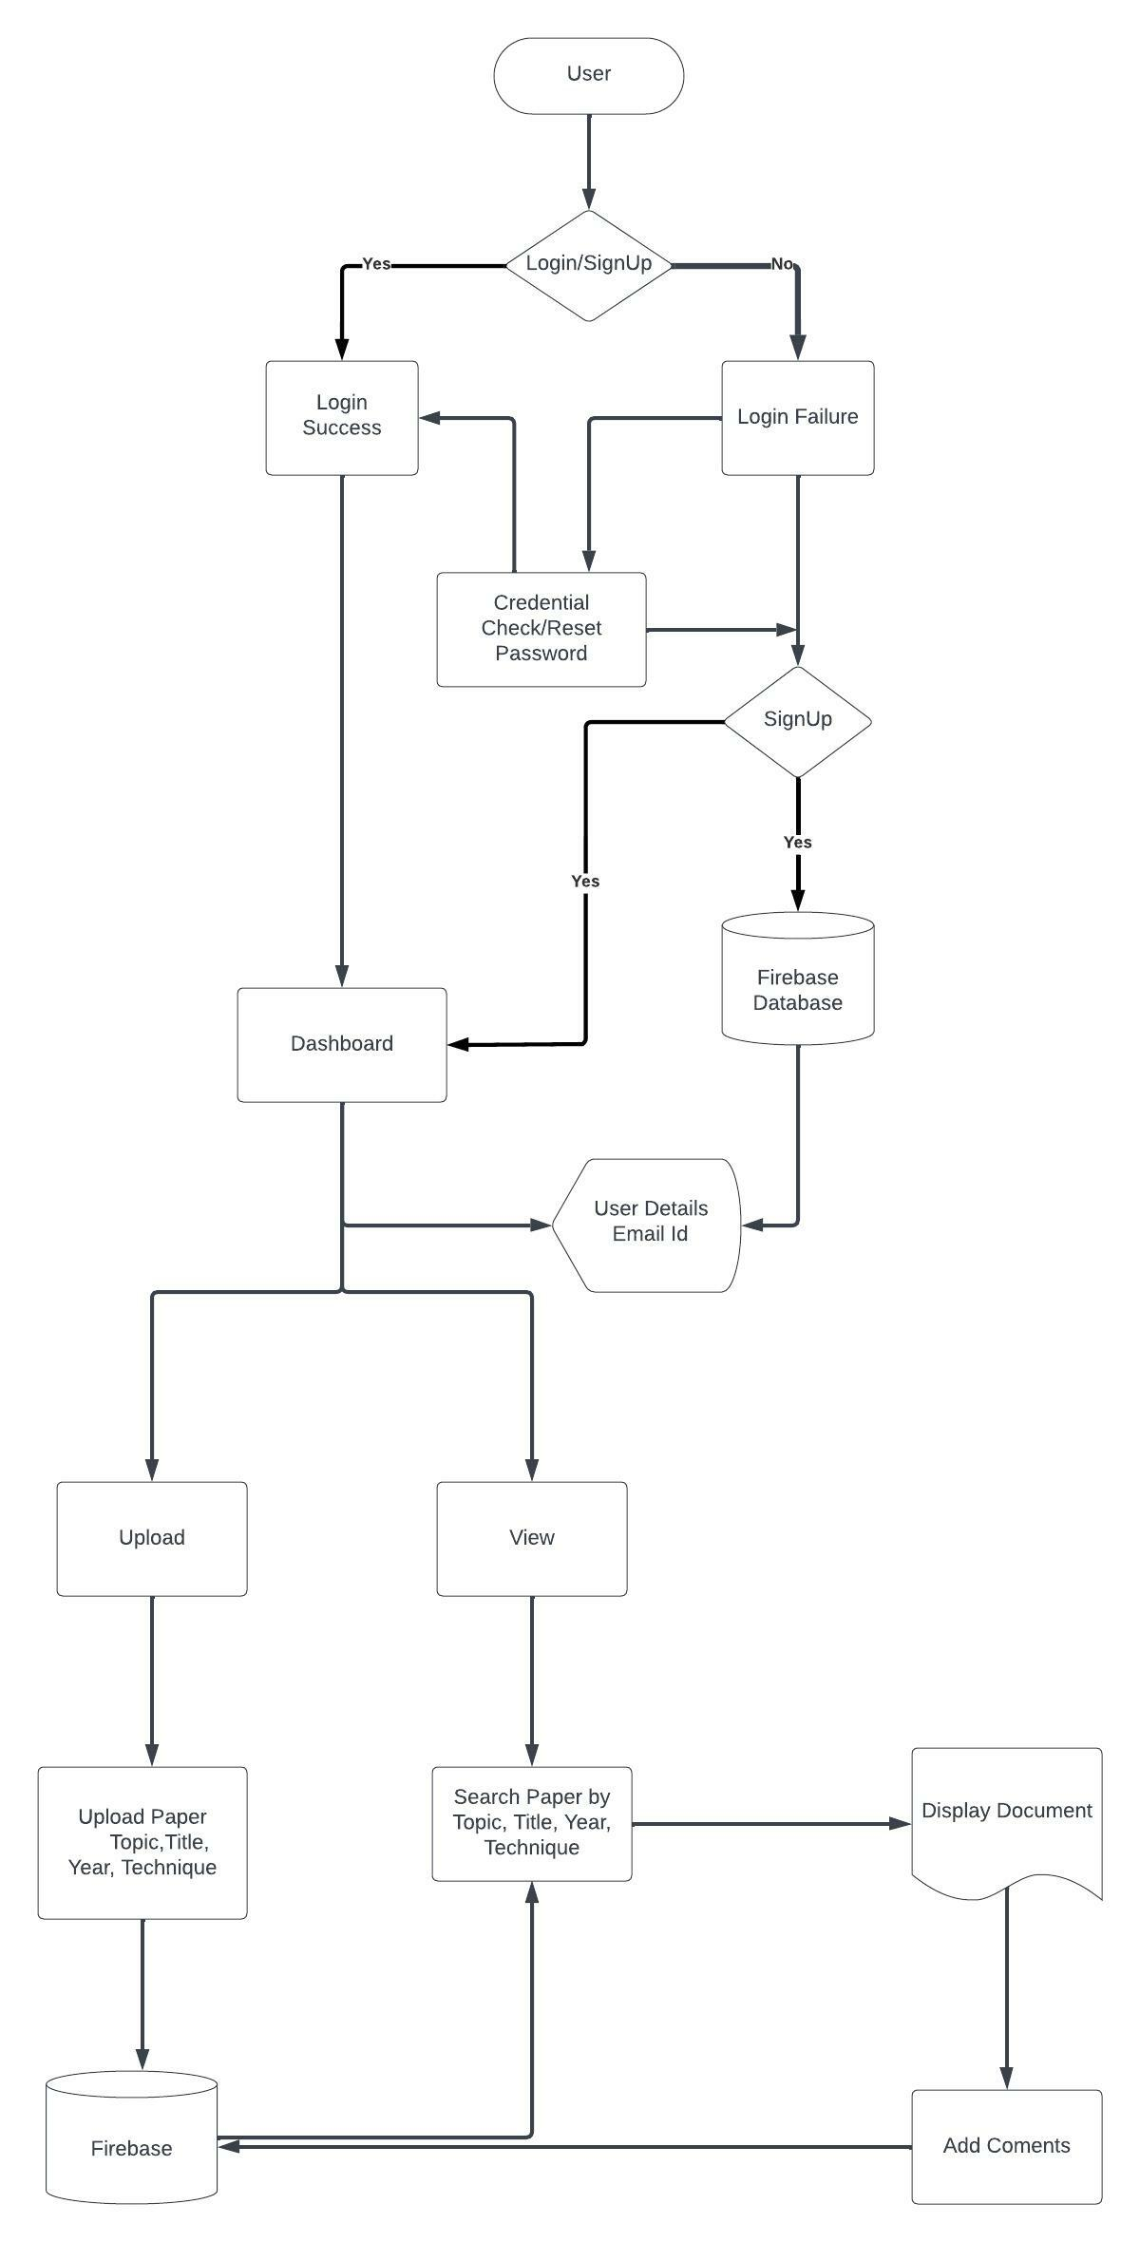

4.2 GUI
As the application consist of various components like login, sign up, upload, search, and view. The process takes place step by step. Below figures are showing login page and dashboard.

5. Steps to create and run the application
5.1. Creating a new React project
- A new React project can be created by using command
“npx create-react-app my-app” where my-app is your app name.
- Developer can use any IDE for developing a react application.
- After the above command is executed successfully a basic react application will be created.
5.2. Managing package.json
- Developer needs to have an idea of how package.json plays an important role in developing an application.
- Package.json consists of metadata where the file includes all the details of application that includes application name, version, dependencies installed and their version and debugging dependencies.
5.3. Adding components
- Components are building blocks for react component. A react application can have many components where developer writes clean and efficient code in a component and embed the component to main file.
- There are 2 types of components in react js. One is functional component and the other is class component.
5.4. Adding database to react application
- To our react application we had chosen Firebase as primary database where our application has authentication, storage and managing the users.
- To make firebase in sync with react application, developer needs to create a project in firebase and choose the application which he/she needs to develop so that firebase provides a snippet code which is ready to use.
- We use the provided snippet by firebase in our react application by creating a new .js extension file.
- By using above file we can import firebase functionalities to our react application.
5.5. Embedding components to App.js
- All the components which were created in react application needs to embed in main file i.e., App.js so that whenever react application is run index.js renders App.js in strict mode and all the components in App.js will be displayed when application is run.
5.6. Running the react application
- After adding all the components to App.js the application needs to be run on the server side.
- React application can be run on the server side using command “npm start” and the application can be viewed on localhost:3000.
- In order to run the application some of the dependencies need to be installed and they can be installed by running the below commands in VS code terminal.
- npm install react-scripts –save
- npm install -S react-router-dom
- npm install --save react-firebase-hooks

